Problem Statement: Prefix notation
Code:
#include <iostream>
#include <stack>
#include <algorithm>
#include <string>
using namespace std;

int getPrecedence(char c) {
if (c == '^') return 3;
if (c == '*' || c == '/') return 2;
if (c == '+' || c == '-') return 1;
return -1;
}

bool isOperand(char c) {
return (c >= 'a' && c <= 'z') || (c >= 'A' && c <= 'Z') || (c >= '0' && c <= '9');
}
string infixToPrefix(string infix) {
reverse(infix.begin(), infix.end());

for (int i = 0; i < infix.length(); i++) {
if (infix[i] == '(') {
infix[i] = ')';
} else if (infix[i] == ')') {
infix[i] = '(';
}
}

string output = "";
stack<char> st;

for (int i = 0; i < infix.length(); i++) {
char c = infix[i];

if (isOperand(c)) {
output += c;
} else if (c == '(') {
st.push(c);
} else if (c == ')') {
while (!st.empty() && st.top() != '(') {
output += st.top();
st.pop();
}
if (!st.empty()) st.pop(); // Pop '('
} else {

while (!st.empty() && getPrecedence(c) < getPrecedence(st.top())) {
output += st.top();
st.pop();
}
st.push(c);
}
}

while (!st.empty()) {
output += st.top();
st.pop();
}

reverse(output.begin(), output.end());
return output;
}

int main() {
string infix = "A+(B*C-(D/E^F)*G)*H";
cout << "Infix: " << infix << endl;
cout << "Prefix: " << infixToPrefix(infix) << endl;
return 0;
}

Output:
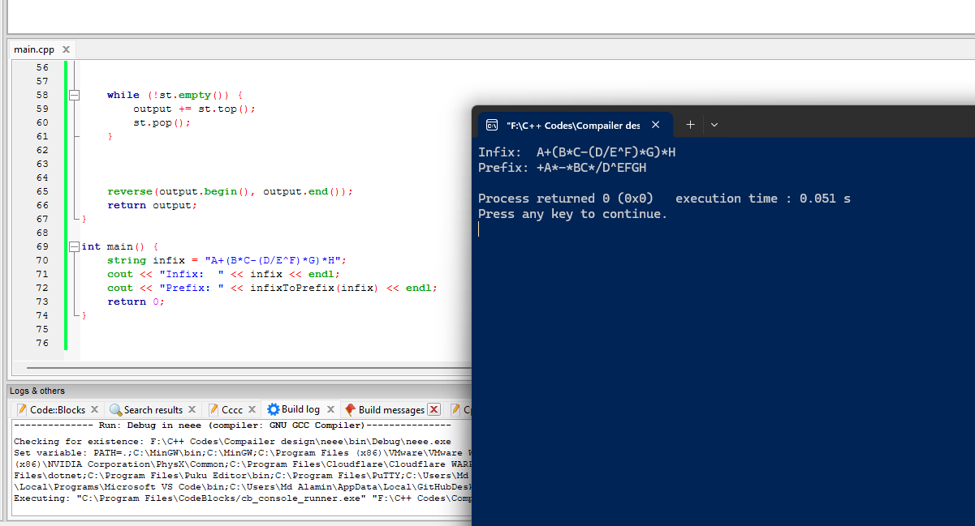

Problem statement: Prefix notation
Code:
#include <iostream>
#include <stack>
#include <string>
#include <cctype>
using namespace std;
int getPrecedence(char op) {
if (op == '+' || op == '-') return 1;
if (op == '*' || op == '/') return 2;
if (op == '^') return 3;
return 0;
}

string infixToPostfix(const string& infix) {
stack<char> s;
string postfix = "";

for (char ch : infix) {

if (isalnum(ch)) {
postfix += ch;
}

else if (ch == '(') {
s.push(ch);
}

else if (ch == ')') {
while (!s.empty() && s.top() != '(') {
postfix += s.top();
s.pop();
}
if (!s.empty()) s.pop(); // Remove '('
}

else {
while (!s.empty() && getPrecedence(s.top()) >= getPrecedence(ch)) {
postfix += s.top();
s.pop();
}
s.push(ch);
}
}

while (!s.empty()) {
postfix += s.top();
s.pop();
}

return postfix;
}

int main() {
string infix = "a+b*(c^d-e)^(f+g*h)-i";
cout << "Infix: " << infix << "\n";
cout << "Postfix: " << infixToPostfix(infix) << "\n";
return 0;
}

Output:
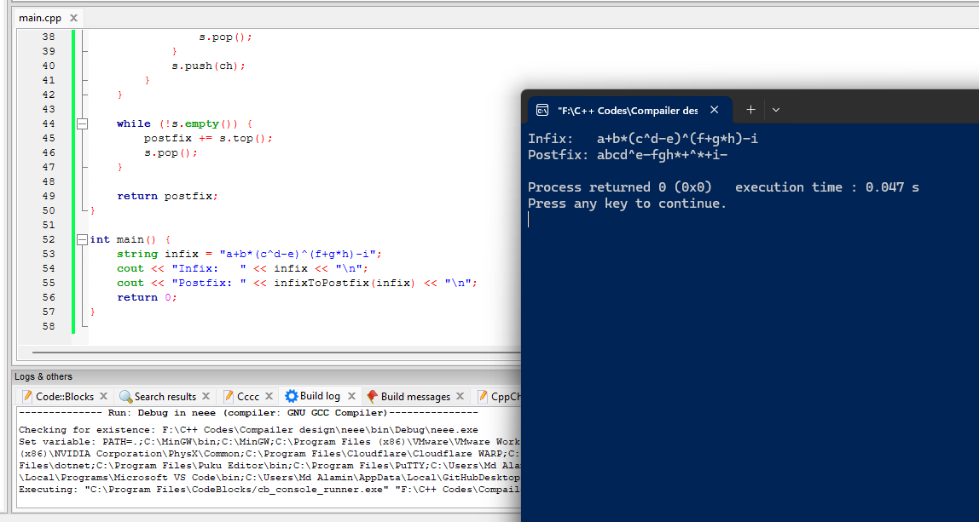

Problem Statement: Find the first set of production rules.
Code:
#include <iostream>
#include <cstring>
using namespace std;

char production[10][20];
char firstSet[10][20];
int n;

void findFirst(char ch, int row)
{
for(int i = 0; i < n; i++)
{
if(production[i][0] == ch)
{
char symbol = production[i][2];

// Terminal
if(!(symbol >= 'A' && symbol <= 'Z'))
{
int len = strlen(firstSet[row]);
firstSet[row][len] = symbol;
firstSet[row][len + 1] = '\0';
}
else
{
findFirst(symbol, row);
}
}
}
}

int main()
{
cout << "Enter number of productions: ";
cin >> n;

cout << "Enter productions (e.g. E=TR):\n";

for(int i = 0; i < n; i++)
cin >> production[i];

for(int i = 0; i < n; i++)
{
char nonTerminal = production[i][0];
findFirst(nonTerminal, i);
cout << "FIRST(" << nonTerminal << ") = { ";

for(int j = 0; firstSet[i][j] != '\0'; j++)
cout << firstSet[i][j] << " ";
cout << "}\n";
}
return 0;
}

Output:
